**Technical Report:**

Analysis of Freedom of Information Request Data from Local Authorities on Crisis Support for Beds and Bedding

By Ali Cooper & Ivy Mullen

February 2024

Contents

Introduction 2

Methodology 4

Research design 4

Sampling 4

Weighting 5

Generalisability 7

Findings 7

Our Freedom of Information request to local authorities in England 8

Growing demand for crisis help with beds and bedding 9

The picture across England 10

Conclusion 11

Appendix 12

# Introduction

This technical report accompanies a shorter briefing: [No crib for a bed - a closer look at bed poverty and the Household Support Fund crisis](https://www.barnardos.org.uk/research/no-crib-bed-closer-look-bed-poverty-and-household-support-fund-crisis).[1] It provides further background and analysis of the Freedom of Information (‘FOI’) data published in that briefing. The aim of our research was to better understand how local authorities’ local crisis support services were being used to address bed poverty, one key aspect of child poverty.

In October 2023 we published our third report on the impact of the cost-of-living crisis on child poverty called ‘No crib for a bed’.[2] This report looked specifically at how rising costs were affecting children’s access to beds and bedding. To inform that research we sent FOI requests to all local authorities in England asking them for the number of applications for beds and bedding they had received in their crisis support services for the last five financial years and how many applications had been successful. We also asked for this information for children’s beds and bedding. We published some of this data in October but have published more data in this report and the accompanying briefing.

A copy of the request is in the Annex below. In our analysis we excluded district councils as the vast majority of them were not responsible for administering their area’s crisis support services. Of the remaining 151 higher tier local authorities within scope 131 responded to our request and 81 provided data.[3]

Analysis of the data reveals that requests for beds and bedding to councils’ crisis support services have grown over the past 5 years. Our key findings are:

* Crisis requests for help with children’s beds and bedding more than quadrupled between 2018-19 and 2022-23, rising from 4,000 to 18,000.
* Over the last five years the rate of successful applications for beds or bedding for children fell from 53% in 2018-19 to 41% in 2022-23. This means that in 2022-23, 10,307 children and families were turned down with more than half of the requests for help with children’s beds and bedding unsuccessful.
* On average, local authorities received 180 crisis requests for help with children’s beds and bedding in 2018-19. By 2022-23 this had risen to 450 requests, an increase of 150%.
* If local authorities had been able to keep up with growing need, the average local authority would have satisfied 365 requests for beds or bedding to children in 2022-23. Local authorities could only satisfied half (51%) of these requests.
* These figures do not show the full picture. We estimate there would have been over 60,000 crisis requests for children’s beds or bedding if there was no postcode lottery in local crisis support in England.

# Methodology

## Research design

Our objective was to understand how local authorities’ local crisis support services were being used to address bed poverty. To do this we chose to send local authorities a standardised FOI request (see Annex 1). This method of data collection was chosen because:

* Local authorities are obliged to comply with FOI requests. We would therefore be more likely to obtain the data this way rather than if we had just asked local authorities for it.
* FOI responses must be provided within 20 working days, ensuring we would get access to the data in a timely manner.
* Our request would likely be received by a FOI lead within the local authority. These members of staff are familiar with collating data requests from across the organisation. This would provide some consistency across local authorities as our data would be collected by employees with similar functions.

We obtained a list of contact email addresses from [www.foi.directory](http://www.foi.directory) and updated our list using local authority websites as needed. We sent out our requests to local authorities on 10 August 2023.

## Sampling

We opted to remove district councils from our analysis. This was because a significant majority of the responses from district councils confirmed that they did not deliver crisis support services as such services were operated by Upper Tier authorities in their area.

We received 131 responses to our request from the 151 local authorities we approached, meaning 20 local authorities did not respond to us. A large number of authorities did not respond to us until after the 20 working days required under the Freedom of Information Act 2000. Where local authorities provided a late response before 1st January 2024, we included their data in our analysis.

Of 131 responses, 81 local authorities were able to provide us with data. The remaining 50 local authorities stated they were unable to provide the information requested. Some of the reasons for not providing the information were:

* Changes implemented to local government between 2019–2023 meant that some local authorities were unable to provide full data sets for the last five financial years. This is because they had not been running for the full timespan requested, with information on previous years no longer being accessible after previous councils were abolished.
* Some local authorities no longer ran a Local Welfare Assistance Scheme, and instead signposted to external support services and therefore did not hold the data.
* The cost or amount of time needed to process the request exceeded the statutory limit and the local authority was not obliged to comply with the request.

Only 23 of the 81 responses that contained data were able to answer all questions fully (i.e. complete the data for all five financial years, for both all requests for beds and bedding and for requests solely for children’s beds and bedding). While this is a small number, we believe our sample is good given that we asked for over 40 data points from each local authority dating back over five financial years.

**Graph A: Overview of responses from local authorities**

## Weighting

In some regions, more local authorities provided us with data than others. For example, in 2022-23, 17 of the 32 local authorities in London were able to provide us with data for the number of requests they had received for beds and bedding in their crisis support services. In Yorkshire and the Humber, 9 of the 15 local authorities were able to provide us with data for the same year. To minimise regional bias and build a picture of the likely demand for beds and bedding across England, we weighted our sample in some of the analysis below and in our briefing. It is clearly indicated where this has been done.

To weight our sample, we calculated the total number of applications and successful applications for each region of England for the last five financial years. We used this to estimate what a typical local authority would receive in each region for each year and then applied these estimated numbers to the local authorities missing from our dataset.

When we weighted the data to estimate values for councils that were missing from our dataset, we only used data from councils that could provide us with both the total number of applications received that year and the number that were successful that year. We did this because we received more data about successful applications and therefore using the dataset as a whole would skew the weighting exercise.

Graph B below shows which region local authorities that provided us with data were from. Graph C shows what it would have looked like if all local authorities had responded and therefore how our sample was weighted.

**Graph B: Responses from local authorities by region of England**

**Graph C: How responses from local authorities were weighted**

## Generalisability

The FOI requests were sent only to local authorities in England, and therefore this analysis should not be used to understand how local crisis support is provided in Scotland, Wales or Northern Ireland. In these nations local crisis support is structured and delivered differently.

Our weighted data can be used to interpret what local crisis support might look like across England. Our weighting is based on the hypothetical assumption that councils that did not provide us with data provided a comparable crisis support service to other local authorities in their region. In other words, the weighted data allows us to understand what local crisis support might look like if a standardised approach to local crisis support was taken across England (i.e. there was no postcode lottery).

We have chosen not to publish specific data for each council as we do not think it is useful to analyse information from councils individually. For example, a local authority may have stopped collecting data on beds and bedding meaning that their dataset was incomplete. This data would not tell provide useful evidence about that local authority’s capacity to deal with bed poverty, however when taken together with data from across England a clearer picture of local crisis support can be developed.

# Findings

## Our Freedom of Information request to local authorities in England

To understand how local crisis support was being used to address bed poverty we sent a Freedom of Information (FOI) request to all local authorities in England in August 2023. We asked them how many applications for beds and bedding they had received in total through their crisis support services across the last five financial years and how many applications had been successful. We asked for the same information in relation to children’s beds and bedding. The request and further analysis of the data is included in a technical report accompanying this briefing.xx

Of the 151 councils in scope,xxi 131 responded to our request and of these, 81 were able to provide data. While our dataset was incomplete, 54% of local authorities provided us with data we could analyse to understand the growing pressures facing their crisis support services.

**Graph 1: All applications to local authority crisis support services for beds and bedding**

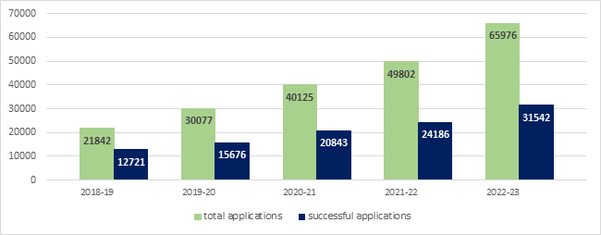

**Graph 2: Applications to local authority crisis support services for beds and bedding for children only**

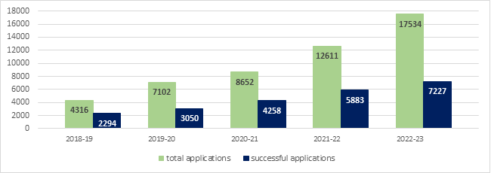

Graph 1 shows that requests to local authorities’ crisis services for help with beds and bedding more than trebled between 2018-19 and 2022-23, increasing by more than 44,000. There was a similar story for children’s beds and bedding where requests for help with children’s beds and bedding more than quadrupled, rising from 4,316 requests in 2018-19 to 17,534 requests in 2022-23. In 2022-23, more than half of the requests for help with children’s beds and bedding were unsuccessful. These figures are likely to represent an underestimate of the extent of need for local crisis support as many local authorities do not widely advertise their local crisis support services.

## Growing demand for crisis help with beds and bedding

The graphs above show a significant growth in demand for crisis support with beds and bedding. This trend could be partially explained by improved local authority record keeping. 42% of local authorities were able to provide us with data related to the year 2018-19. This rose to 50% of local authorities who were able to provide data for 2022-23. However, when looking at the average number of requests which each local authority received, a similar rising trend emerged.

**Graph 3: Average number of requests for help with beds and bedding by each local authority**

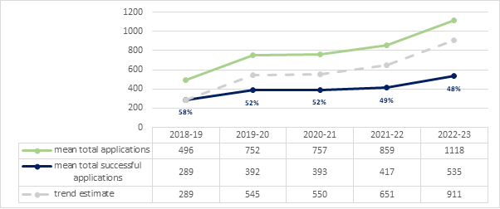

**Graph 4: Average number of requests for help with children’s beds and bedding by each local authority**

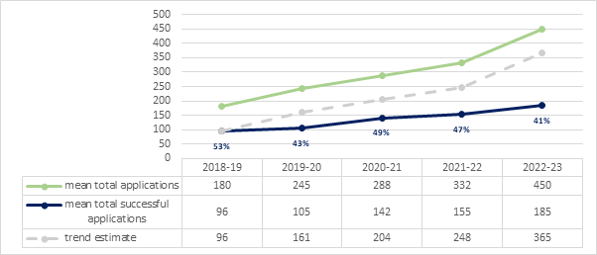

Graphs 3 and 4 show that local authorities are under increasing pressure to provide help with beds and bedding in their crisis support services, yet are struggling to keep up with demand.

Graph 3 shows that in 2018-19, on average, local authorities received 496 applications for help with beds and bedding in their crisis services. By 2022-23, the average number of requests received had more than doubled to 1,118. Over that period the success rate of applications fell by 10% so that by 2022-23 only 48% of requests for help were successful.

Graph 4 illustrates an even starker change for children’s beds and bedding. On average, local authorities received 180 requests in 2018-19 with an average success rate of 96 applications. By 2022-23, the success rate had fallen 12% to 41% with only 185 of the 450 requests being successful.

On both Graph 3 and 4 we have plotted a trend line, which illustrates how many successful applications there would have been if the gap between successful applications and total applications in 2018-19 had remained the same. In Graph 4 this shows that, on average, if councils had been able to keep up with demand, 365 requests for children’s beds and bedding would have been provided by the average council in England. In reality councils were only able to respond to 185 requests on average.

## The picture across England

In some regions, more local authorities provided us with data than others. This may have been because:

* the local authority did not run a crisis support service,
* they only stored successful requests,
* their data storage systems changed making data from previous years inaccessible, or
* the cost of responding to the FOI would exceed the threshold.

In order to minimise regional bias and build a picture of the likely demand for beds and bedding across England we weighted our sample. We estimated the likely figures for local authorities who were missing from our dataset, based on how other local authorities in their region had responded.

**Graph 5: Estimated applications to local authority crisis support services for beds and bedding across England**

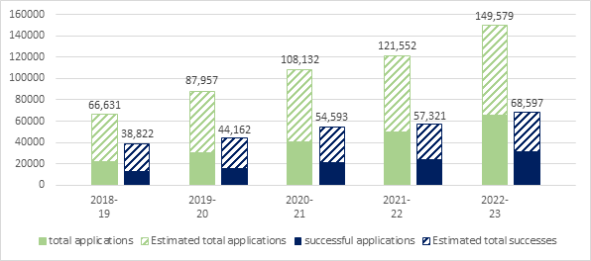

In 2022-23, we estimate there would have been almost 150,000 requests for help with beds and bedding to local authorities and 69,000 would have been successful if there was a minimum standard level of crisis support across England.

**Graph 6: Estimated applications to local authority crisis support services for beds and bedding for children across England**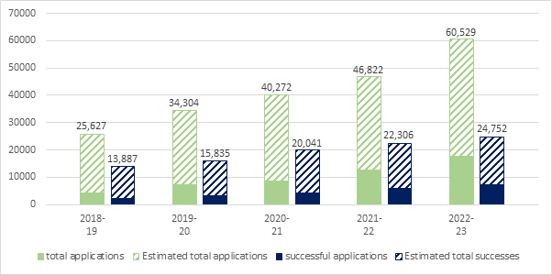

While fewer local authorities were able to provide us with data specifically for children’s beds and bedding, we estimate there would have been 26,000 applications across England in 2018-19 and 14,000 applications would be accepted. By 2022-23, we know that numbers of applications were increasing significantly. We estimate there would have been 61,000 applications for children’s beds and bedding to local authority crisis support services in 2022-23 if there was a minimum standard level of crisis support across England but only 25,000 applications (41%) would have been successful.

# Conclusion

Overall, our findings show that local crisis support services offered by English local authorities have been under increasing pressure for crisis requests for help with beds and bedding. When analysing the data provided by local authorities, we found that total requests had more than trebled in the 5 years covered by this study, and children’s requests had more than quadrupled. As demand increased, more than half of the requests for children’s beds and bedding each year from 2019-20 onwards have been unsuccessful.

Crisis support services are struggling to keep up with demand. While the average yearly number of requests for crisis support sent to each local authority has more than doubled in the timeframe covered by this research, the success rate of applications fell by 10% for total requests and 12% for requests for children. For councils to be able to meet the same level of demand in 2022-23 as they had in 2018-19, there would need to be a 35% increase in total successful applications, and 40% for children’s beds and bedding.

These statistics may be being affected by changes in response rate, as we found that 50% of local authorities could provide us with data in 2022-23 but only 42% in 2018-19 were able to do so. However, as the weighted data used to calculate overall trends identifies the same pattern and our conclusions align with other published research on the effects of the Cost-of-Living crisis and information we have heard from councils about growing demand, we believe that this data is likely to be representative of patterns across England.

Finally, we estimate that across England there would be approximately 61,000 applications for children’s beds and bedding to local authority crisis support services in 2022-23 if there was a minimum standard level of crisis support across England. We estimate 25,000 would be successful.

# Appendix

*The FOI request submitted to local authorities*

Dear FOI request team,

I am seeking information on the number of applications to your crisis support services for help with beds and bedding. These services could include a local welfare assistance scheme (‘LWA scheme’), the Household Support Fund, Covid grants, or any other type of crisis support.

LWA schemes are typically a named service to which members of the public can apply for crisis support (such as for furniture or help with bills) and provide direct grants (cash or in kind) to an individual or household.

Would you be able to provide the number of applications that match the criteria in column 2 to column 5 for the last 5 financial years? Please could you provide this information in the table below and where the information is incomplete, please also indicate this in the table.

|  |  |  |  |  |
| --- | --- | --- | --- | --- |
| Column 1 | Column 2 | Column 3 | Column 4 | Column 5 |
| No. of applications | | No. of successful applications | |
| Financial year | Number of applications to your crisis support services where applicants have sought help with access to any of the following items: Beds, cots, bedding or mattresses. | Number of applications in column 2 where the application was made for a child (i.e. the application was for beds, cots, bedding or mattresses for a child) | Number of applications in column 2 that have been successful. (i.e. help with beds, cots, bedding or mattresses was provided.) | Number of applications in column 3 that were successful (i.e. help with beds, cots, bedding or mattresses for a child was provided.) |
| 2022-23 |  |  |  |  |
| 2021-22 |  |  |  |  |
| 2020-21 |  |  |  |  |
| 2019-20 |  |  |  |  |
| 2018-19 |  |  |  |  |

Barnardo’s will use the information provided to inform research on bed poverty. This research will be used in our work with the Government on strengthening support for children living in poverty.

I would be grateful if you could please reply confirming you have received this request. If you have any problems with the request, please feel free to email me (ivy.mullen@barnardos.org.uk).

I hope to hear from you within the statutory 20 working days (by Thursday 7th September).

Kind Regards,

**Ivy Mullen**

Barnardo’s Head Office, Tanners Lane, Barkingside IG6 1QG

1. Barnardo’s (2024), ‘[No crib for a bed: a closer look at bed poverty and the Household Support Fund crisis](https://www.barnardos.org.uk/research/no-crib-bed-closer-look-bed-poverty-and-household-support-fund-crisis)’
2. Barnardo’s (2023), ‘[No crib for a bed: the impact of the cost-of-living crisis on bed poverty](https://www.barnardos.org.uk/research/no-crib-impact-cost-living-crisis-bed-poverty)’
3. A full list of councils in England was taken from the UK Government’s website: UK Government (2023), ‘[List of councils in England by type](https://assets.publishing.service.gov.uk/government/uploads/system/uploads/attachment_data/file/1140054/List_of_councils_in_England_2023.pdf)’