**YC CARD**

**As a young carer I might need**:

**Student name:**

**Year/Form:**

**Issue date:**

**Review date:**

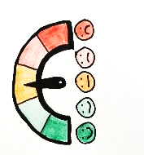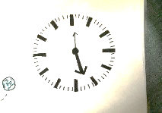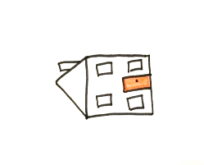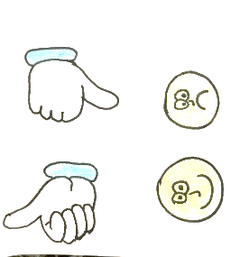

**Time out**

**To contact home**

**To be late**

**To be understood**

**Extra time**

**See my passport for more information!**

**Name of young carers lead:**