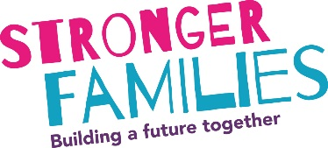
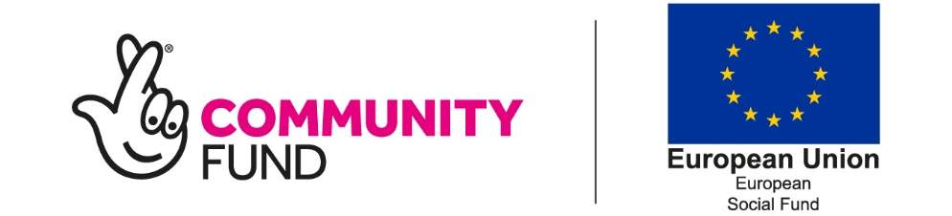

Referral and Initial Consent Form
Information in bold is required information and must be included in all referrals. If unknown please state.
Participant details and consent cccccccccccccccccccccccccccccccccccccccccccccccccccccccccccccc
Name: __________________________________ | Gender: _________________________________
DOB: ___________________________________ | Telephone: ______________________________
Address: ________________________________ | Email: ___________________________________
Postcode: _______________________________ | Referral Date: ____________________________

☐ I consent to my name, contact details and personal information on this form being shared with Stronger Families Partners in association with Building Better Opportunities projects who will contact me to discuss the programme. We will contact you to discuss the programme, if you are eligible and you agree to join the Stronger families Programme we will share your information with a Stronger families Partner and a Key Worker will contact you to sign you up to the programme. Your information will be kept secure.

Please see our privacy statement here Bradford Stronger Families | Barnardo's (barnardos.org.uk)

Stronger Families’ partners - Leeds: Barca, Learning Partnerships, Health for All, Barnardos, HumanKind. Bradford: Barnardos, James, Himmat, The Bridge, Brathay
Eligibility and support needed:ccccccccccccccccccccccccccccccccccccccccccccccccccccccccccccccc
We need to check that the person you are referring is eligible to join this programme. The programme is open to individuals, with a dependent child, who are not in paid work and are eligible to work in the UK. We are unable to work with individuals who are on zero-hour contracts, furlough and maternity or sick leave as they are not eligible for the programme.
Please tick the following that apply:
☐ Participants age 18+ (or 17+ but not in education) and with at least one dependent child (doesn’t have to live in same household but must have contact)
☐ Is economically inactive (i.e. they are not in paid employment or self-employment and are not available for or not seeking work including not on furlough, sick leave, maternity leave or zero hours contract)
☐ Is unemployed (i.e. they are entirely without work, but are available for and actively seeking work. They will usually be registered unemployed and be in receipt of unemployment benefits.)
☐ To my knowledge this participant has the right to work in the UK

Please confirm which evidence participant has out of the following:
☐ Birth Certificate ☐ EUSS ☐ Bi-Metric Card
☐ Visa with leave to remain ☐ Current Passport (which country?)

Please specify which benefits are being claimed
(if any/known):
Number of dependent children:

The participant needs support for themselves or their family for the following: (tick all that apply)
☐ Low school attendance ☐ Anti-Social behaviour
☐ Domestic violence ☐ Financial exclusion / debt
☐ Physical health ☐ Housing
☐ Social Emotional Mental Health ☐ Other (Please specify):

If yes to any of the support needs above – please explain in more detail here:

Is an interpreter needed? If yes please specify language:

Please specify here if there’s any other agency/service involved e.g. social work, third party organisation *
(Providing these details gives Stronger Families consent to contact these people so please discuss this with anyone being referred to our service)
Agency/Name | Contact Info (email/phone number) | Service

Is there any risk to workers if they visit this participant? If yes please explain:

Referrer Information *cccccccccccccccccccccccccccccccccccccccccccccccccccccccccccccccccccccccc
Referrer Name:
Company/Service:
Email:
Phone:
Where did you hear about Stronger Families? *cccccccccccccccccccccccccccccccccccccccccccccc

Please send this referral to one of the below emails. Please note that if the participant lives in Leeds the referrals will need to go to Barca-Leeds and if they live in Bradford the referral will need to go to Barnardos.
Leeds | Bradford
Please password protect documents sent via email/or send via secure email.  Strongerfamilies@barca-leeds.org or Stronger.families@wyfi.cjsm.net (can only be sent to this address via another secure account) | Please password protect documents sent via email/or send via secure email. StrongerFamiliesBradford@barnardos.org.uk
We are happy to take referrals over the phone: 0113 386 9900 / 07857 625 442 / 07594 088 051 | We are happy to take referrals over the phone: 01274 513 300 / 07894 708 337

