 |  |   ACTION WITH YOUNG CARERS WIRRAL  REFERRAL FORM |  |  |  | Barnardo’s Action with Young Carers Wirral  The Community Village  334 New Chester Road  Rock Ferry  Wirral CH42 1LE  Tel: 0151 228 4455
Personal Details
Young person’s name  (or other known name): |  |  |  | Gender Identity: Female  Male Female Self defined – Please state:
Address: |  |  |  | Post code:
Date of Birth: |  |  |  | Telephone Numbers (landline & mobiles):
Email address:

Parent/Carer’s details

Name: |  |  |  | Relationship to child/young person
Address and post code(if different to above):

Telephone Numbers (landline & mobile): |  |  |  | Email address:
OTHER PEOPLE IN THE HOUSEHOLD
Surname | Forenames |  | Gender Identity |  | D.O.B. |  | Relationship to YP
Ethnicity: (please tick appropriate box)
White |  | Black/Black British |  | Asian/Asian British |  | Mixed
White British |  | Caribbean |  | Indian |  | White/Black Caribbean
White Irish |  | African |  | Pakistani |  | White/Black African
Other White |  | Other Black |  | Bangladeshi |  | White/Asian
Indian |  | White/Black Caribbean |  | Other Asian |  | Other Mixed
Chinese |  | Other Ethnic |  | Preferred Language:  (Other than English)
Chinese |  | Any Other

Disability: If yes could you provide details:

Any communication/language needs (numeracy/literacy/interpreter) :

Barnardo’s Wirral Young Carers strive to be sensitive to young people’s/families religious, cultural, racial, gender, sexuality and disability issues/preferences. Please provide any information in relation to the above that would be helpful for us to know about:

OTHER AGENCIES INVOLVED

Agency | Worker’s Name | Contact Numbers

School/College information

School/College attended | Key Contact | Contact Number

Levels of Need (to be completed by professionals only)

Level 2 – Single Agency | Level 3 – Multi-Agency | Level 4 Social Care

Any relevant assessments attached i.e. TAF Yes No

Cared for Relative:
Name: | DOB: | Relation to Young Person/Child:
Nature of Illness/Disability:

What caring tasks does the child/young person engage in?

Tasks | Yes | No
(1) Domestic tasks ie cleaning, vacuuming
(2) Household management ie Food shopping
(3) Personal care ie washing, dressing
(4) Emotional care ie supports
(5) Sibling care ie takes to school, cares for
(6) Financial/practical care ie Money Management
(7) Other

Is the child or young person the primary carer or does someone else also provide care for ill or disabled person? * shares caring role with siblings

Please identify, in what way, the child/young person’s caring responsibilities, have an impacted on them:

Educationally
Socially
Emotionally

Please tell us of any support that has already been provided in relation to this child/young person’s caring responsibilities and who has provided it:

Health and Safety risk factors

Are you aware of any Health and Safety/risk factors that we need to be aware of when working with the family/children/young people? (E.g. substance/alcohol misuse, anti-social or threatening behaviour issues, violent incidents, dangerous dogs/knives/weapons etc?
Yes No

If yes please provide details:

REFERRER’S DETAILS

Person making referral (PRINT NAME) | Agency | Job Title
Email: |  | Telephone
Date of referral:

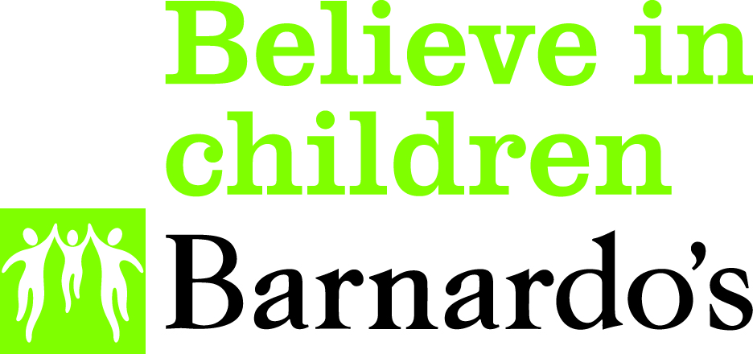
Barnardo’s

Wirral Action with Young Carers
Parental Agreement to Receive a Service
(required for young people who are under 16)
Name of child or young person
Age of child or young person
Name of *person giving agreement
Relationship pf person giving agreement to the child
Name of worker obtaining parental agreement
*If this is not a parent it must be someone with legal responsibility for the child or young person.
 | Y | N
The details of the service being provided have been explained to me
I understand that a record will be maintained of the service provided by Barnardo’s and Wirral Council. Please view Privacy Notices:
Privacy notice | Barnardo's (barnardos.org.uk)

Principal Privacy Notice | www.wirral.gov.uk

I understand that I may withdraw agreement for the provision of this service at any time ; however the record of the service provide will be retained by Barnardo’s and Wirral Council as explained in the Privacy Notices.
I give consent for my child to receive a service from Barnardo’s Wirral Action with Young Carers
Signature of parent giving agreement/verbal agreement
Date
Please return this signed form with the completed referral form
by secure e-mail to wirral.services@barnardos.org.uk
or
Barnardo’s Wirral Action With Young Carers Service, Shaftesbury Youth Centre, 60 Mendip Road Birkenhead, Wirral, CH42 8NU, Tel: 0151 228 4455
Barnardo’s Registered Charity Nos. 216250 and SC037605
A copy of this document is to be given to the parent when the agreement is signed or to the young person if 16 or over.

