***Please***

**WIRRAL INDEPENDENT VISITOR SERVICE**

**REFERRAL FORM**



**The Lauries**

**142 Claughton Road**

**Birkenhead**

**Wirral**

**CH41 6EY**

**0151 650 5488**



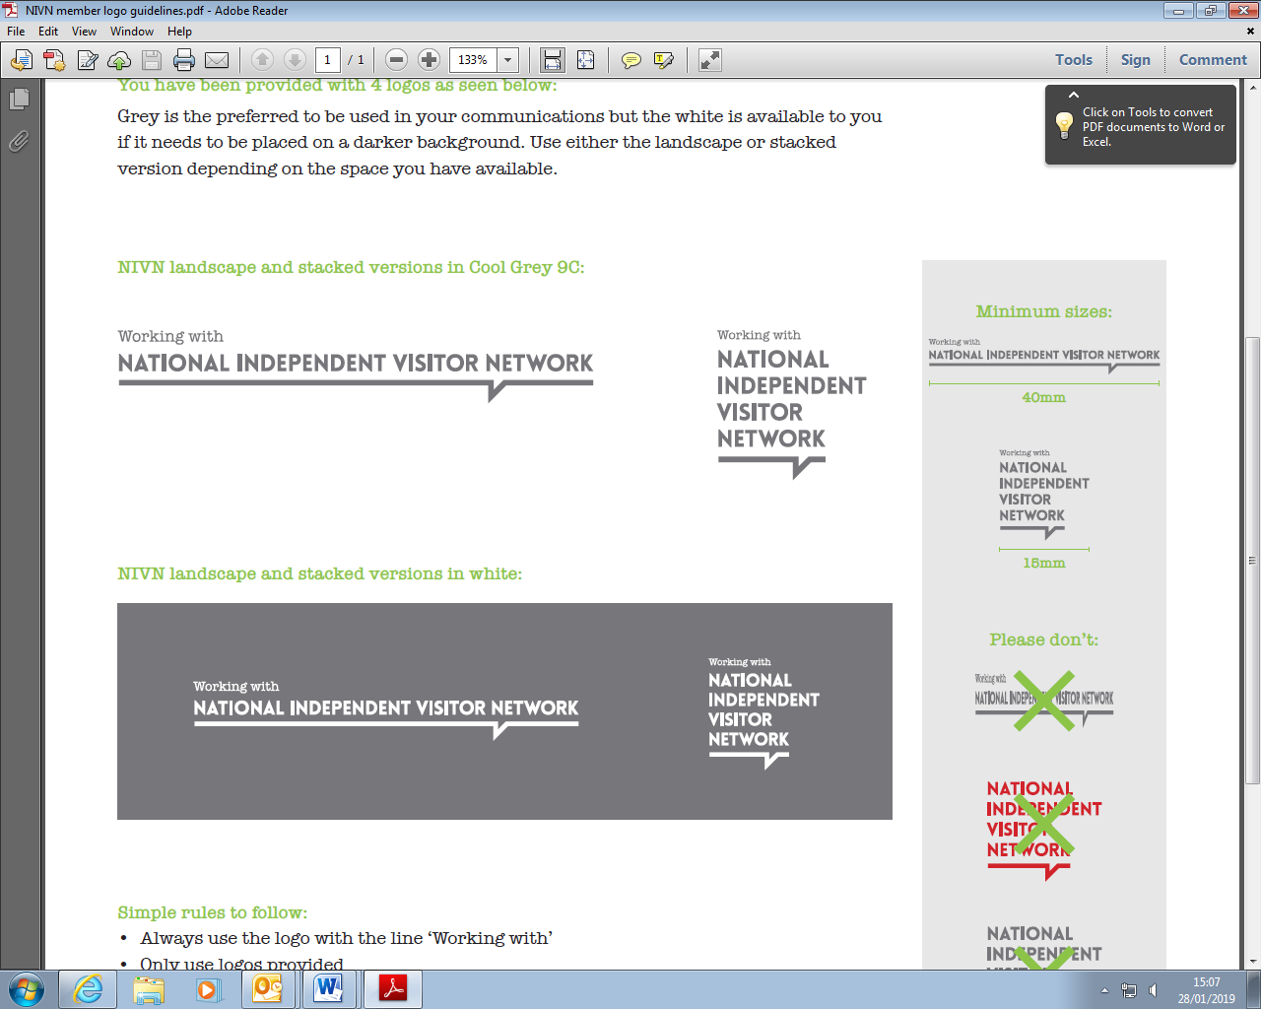

|  |  |  |  |
| --- | --- | --- | --- |
| **CHILD/YOUNG PERSON’S DETAILS** | | | |
| **Full Name:** | | **Date of Birth:** | |
| **Address:** | | **Phone Number *(please provide the young person’s contact number if appropriate, as well as the number for their carer:*** | |
| **Gender: Male  Female  Self defined  (please explain)** | | | |
| **Ethnicity:** | | **Religion:** | |
| **Disability/Health Issues:** | | | |
| **Type of placement:** | | **Contact person at placement:** | |
| **Social Worker/Personal Advisor (name, contact number & email address):** | | | |
| **IRO (name, contact number & email address):** | | | |
| **Why does this child/young person require Independent Visitor?** | **Child/young person’s perspective:** | | |
| **Referrer’s perspective:** | | |
| **How would this child/young person benefit from having an Independent Visitor?** | **Child/young person’s perspective:** | | |
| **Referrer’s perspective:** | | |
| **Outline any contact the child/young person has with family members** |  | | |
| **I confirm that this referral has been discussed with the child/young person** | **YES/NO** | | |
| **Does the child/young person have any particular needs or issues that an Independent Visitor may need to be aware of e.g. cultural requirements?** | | | |
| **Name of referrer:** | | | |
| **Relationship to child/young person:** | | | **Date:** |

***Please return this form via secure email to wirral.services@barnardos.org.uk***

|  |  |  |
| --- | --- | --- |
| Please thoroughly detail any identified risk factors/issues/concerns that would help us to plan support and ensure that the child/young person and an Independent Visitor can engage in the service safely.  This should include guidelines in how to deal with the child/young person’s behaviour, any particular precautions that should be observed, identified triggers and how these should be responded to.  This information will help us to develop a support plan for the child/young person, identify the right Independent Visitor and determine whether an individual risk assessment is required. |  |  |

|  |  |  |  |  |  |  |
| --- | --- | --- | --- | --- | --- | --- |
|  | **Issues or concerns that should be taken into consideration in relation to:** | **Yes**  **if yes, please provide details** | **No** | **Details**  ***Please focus answers on the past 6 months******but provide any historical information if appropriate.*** | **Frequency in the past 6 months** | **Suggestions/recommendation as to how Independent Visitor should respond/support the young person** |
| **Health** | Physical health/medical conditions/allergies |  |  |  |  |  |
| Use of medication |  |  |  |  |  |
| **Disability** | Physical disability |  |  |  |  |  |
| Learning disability/difficulty |  |  |  |  |  |
| Mobility or access needs |  |  |  |  |  |
| Social and communication needs |  |  |  |  |  |
| Capacity to retain/ understand information |  |  |  |  |  |
| **Mental Health** | Mental health condition |  |  |  |  |  |
| Poor emotional wellbeing |  |  |  |  |  |
| Self-harm *(include date of most recent incident)* |  |  |  |  |  |
| Other |  |  |  |  |  |
| **Vulnerability** | Risk taking behaviour *(please provide details)* |  |  |  |  |  |
| Ability to keep self-safe |  |  |  |  |  |
| Risk of absconding  *(please include date of most recent occurrence)* |  |  |  |  |  |
| Substance misuse |  |  |  |  |  |
| At risk of sexual, criminal, financial exploitation |  |  |  |  |  |
| Other |  |  |  |  |  |
| **Risk to Others** | Aggressive or violent behaviour to others |  |  |  |  |  |
| Inappropriate sexualised behaviour |  |  |  |  |  |
| Allegations against staff |  |  |  |  |  |
| Supervision/ratio requirements |  |  |  |  |  |
| Health & safety risk factors to be aware of when visiting the young person at their home address |  |  |  |  |  |
| Other behaviour issues |  |  |  |  |  |
|  | **Please detail any additional information that the service should be aware of:** | | | | | |

***Please return this form via secure email to*** [***wirral.services@barnardos.org.uk***](mailto:wirral.services@barnardos.org.uk)

***For office use only:***

**Individual Risk Assessment required: Yes/No**

**Date:**

**Staff Name:**