
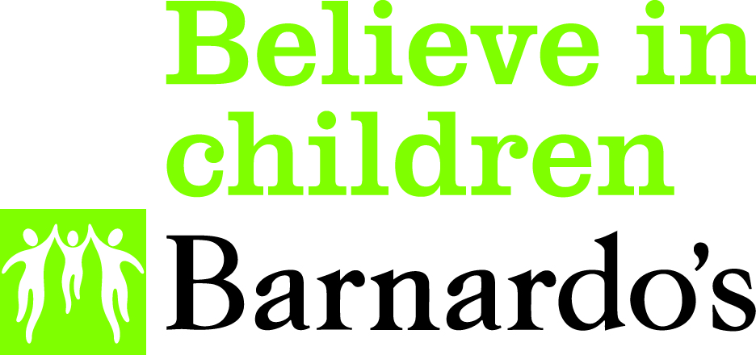

Barnardo’s Wirral Advocacy and Independent Visitors Service

Children Looked After Advocacy
Referral Form

Name of Child/YP
Placement Address
Placement type
Young person’s contact number |  | Email address
DOB |  | Age
Gender | Male | Female | Self defined (please state)
Ethnicity |  | Religion
Disability | Yes / No | If yes, provide details
Carer/key worker’s name |  | Relationship
Tel Number |  | e-mail address
Social Worker | Name | Tel no and e-mail address | Team
IRO | Name | Tel no and e-mail address
School
Contact in school | Name | Tel no and e-mail address
Legal Status
Date of next
CLA Review
Dates and details of any other relevant meetings

I confirm that the child/young person is a Wirral Looked After child.

Please give the reasons the child/young person requires support from an Advocate.

Are there any health and safety risk factors for us to be aware of? eg visiting home address

Other Professionals involved:

Name: | Role | Contact Details

I confirm that this referral to Barnardo’s WAIV CLA Advocacy Service

has been discussed with the child/young person and they have agreed
to the referral being made.

Referrer Details:

Name of referrer
Relationship
Address
Tel Number |  | Mobile:
Email
Date

Please return the completed form by secure e-mail to wirral.services@barnardos.org.uk
or send to;
Barnardo’s WAIV Service,
The Lauries,
142 Claughton Road,
Birkernhead, Wirral
CH41 6EY

Tel 0151 650 5488

