
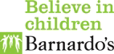

Barnardo’s Wirral Advocacy and Independent Visitors Service

Child Protection Advocacy
Referral Form

Name of Child/YP
Address
Contact number |  | e-mail address
DOB |  | Age
Gender | Male | Female | Self defined (please state)
Ethnicity |  | Religion
Disability | Yes/No | If yes, provide details
Name(s) of Parent(s)

Contact numbers

E-mail address of parent (s)

Social Worker | Name | Tel no and e-mail address |  | Team
IRO | Name | Tel no and e-mail address
School
Contact in school | Name | Tel No and e-mail address
Date the child/young person became subject to a CP Plan |  | Category

Has a parent agreed to this referral being made and signed the
attached agreement form? Yes No

Has the referral been discussed with the child/young person? Yes No

We can only accept referrals if Advocacy has been discussed with the young person and written agreement (using the attached form) given by a person with parental responsibility if the young person is under 16.

Please give the reasons the child/young person requires support from an Advocate.

Date of next Core Group meeting
Date of next Review Conference

Are there any health and safety risk factors for us to be aware of?

Other Professionals involved:

Name and agency; | Contact Details (phone number and e-mail address

Referrer Details:

Name of referrer
Relationship/role
Address/Team
Tel Number |  | Mobile:
Email
Date

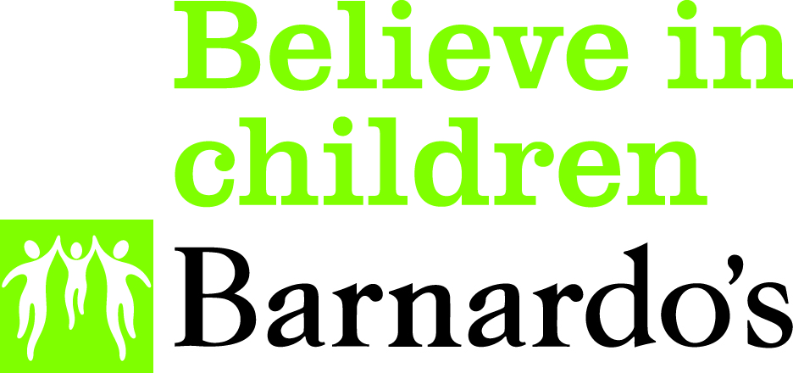

Barnardo’s WAIV

Child Protection Advocacy
Parental Agreement to Receive a Service
(required for young people who are under 16)
Name of child or young person
Age of child or young person
Name of person giving agreement*
Relationship of person giving agreement.
Name of worker obtaining parental agreement
*If this is not a parent it must be someone with legal responsibility for the child or young person.
 | Y | N
The details of the service being provided have been explained to me
I understand that a record will be maintained of the service provided by Barnardo’s and a Privacy Notice has been provided to me.
I understand that I may withdraw agreement for the provision of this service at any time ; however the record of the service provide will be retained by Barnardo’s as explained in the Privacy Notice.

I give consent for my child to receive a service from Barnardo’s WAIV Service
Signature of parent giving agreement
Date

Please return this signed form with the completed referral and consent forms
by secure e-mail to wirral.services@barnardos.org.uk
or
Barnardo’s WAIV Service,
The Lauries,
142 Claughton Road,
Birkernhead, Wirral
CH41 6EY

Tel 0151 650 5488

Barnardo’s Registered Charity Nos. 216250 and SC037605
