

YCARE
(Young Carers Additional Resources in Education)
Contents Page
Young Carers Additional Resources in Education (YCARE) is designed to give schools, colleges and educational settings, the opportunity to identify young carers and recognise the caring responsibilities they might have. As an educational setting, these resources are a way of acknowledging your support to young carers. These resources ensure that young carers are aware of who the designated young carers lead is and what support is available to them. The young carers lead would be there to support young carers and give assurance to other staff members that the student is entitled to the support they are requesting. This means young carers don’t have to explain their story to multiple individual staff members to access their support. The ‘about me’ and young carers card are designed to be personalised, not only to each young carer’s needs, but also to what you as a setting are able to offer. Some suggestions are; needing extra time to complete homework, needing time out of class to compose themselves if they become distracted or distressed, to have an alternative option to after-hours detentions or revision clubs, recognition that they may be late, access to a phone to contact home, but overall to be understood.
YCARE includes:
Checklist for educational settings 2
Guidance and Information on using YCARE 4
Lancashire Young Carers Service Information 6
A suggested young carers policy 8
Helpful services 9
Links to relevant resources 10

Checklist for educational settings
This is a suggested list of support that can be implemented within your setting to create a ‘young carer aware’ environment that promotes identifying and supporting young carers in your setting.

Helpful documents
☐ A young carer ‘about me’ page to complete with the young person to discuss what support they would find helpful in school/college and reviewed termly.
☐ A young carer card to use within school/college.
Identification and assessment
☐ Use of the MACA and PANOC document.
☐ Access to a referral form for Lancashire Young Carers.
☐ Adopt a healthy attitude to illnesses to reduce the stigma attached to mental health and disabilities.
☐ Included in the school census as a young carer.

Information for young carers
☐ A named member of staff/key contact for young carers to talk to within school/college.
☐ Information about wider support for young carers and their families.
☐ Information about what support school/college can offer to young carers.
☐ Information and/or posters about young carers on a noticeboard, webpage or included in literature.

Emotional support for young carers
☐ More flexible opportunities to talk with staff.
☐ A young carers peer support group in school/college.
☐ Option to access the school/college counsellor or pastoral worker.

Practical support for young carers
☐ Flexibility with homework, detentions, options to contact home.
☐ Concessions and flexibility with travel to school and after school/college clubs (where appropriate).
☐ Concessions with school/college trips etc for young carers (where appropriate).

Wider support
☐ Improved and accessible communications with parents/guardians.
☐ Links with a project worker at Lancashire Young Carers (where applicable).
☐ Opportunities for young carers to share feedback on their school/college experience.
☐ Refer/Signpost/Liaise with appropriate agencies (Kooth, CFWS, Barnardo’s etc.).
☐ Attend a Lancashire Young Carers training session around identifying and supporting young carers.
☐ Provide assemblies raising awareness of young carers (Lancashire Young Carers can support with this).
☐ Acknowledge YCAD (young carers action day) in school/college which happens in March.

Guidance and Information on using YCARE
Who is a young carer?
A young carer is under the age of 18 and providing regular and ongoing care and/or emotional support to a family member who is physically or mentally ill, disabled, or misuses substances. Some young carers may not require additional support, others may need some support in school/college. Young carers who are significantly impacted by their caring role may require a referral to Lancashire Young Carers service.
What does a young carer do?
Young carers may provide emotional and/or practical support at home. They may wish to complete a questionnaire document called ‘MACA and PANOC’ which can help school/college to understand what their caring responsibilities are and how it makes them feel. (Guidance on the MACA and PANOC is included in YCARE).
What is the young carer ‘about me’ page?
This is a document designed for the young person to complete with a member of staff. It will give an opportunity to discuss any difficulties and what will help you in school/college. This should be reviewed every term, but changes can be made at any time.
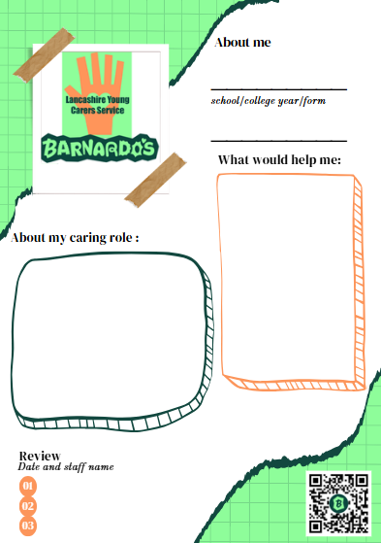

What is the young carer card?
The young carer card is to use discreetly in school/college to let a teacher or staff member know that they need specific support around their caring role. This could be around needing to talk to someone about feelings, contacting home, being late to school or needing extra time for homework. The young carer and designated support staff member will have discussed what support is available in school/college when completing the young carer passport.
What does the young carer card look like?
The card is just bigger than a credit card and can be printed and laminated for the young carer to keep hold of. It will include their name, year/form, important dates, and a photo. On the back are some examples of what help might be needed during the school/college day. It will also include the name of the young carers lead and a family contact number.
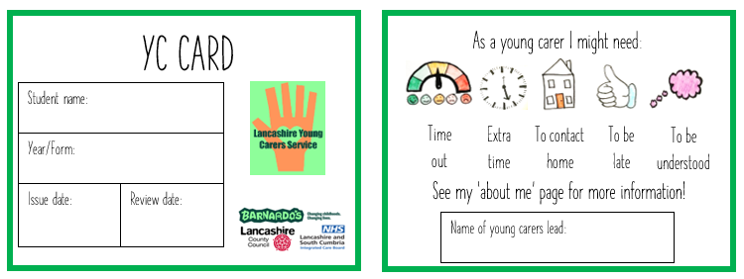

Lancashire Young Carers Service Information
Lancashire Young Carers Service
Barnardo’s, 1 Dorothy Avenue, Leyland PR25 2YA Tel: 01772 641002
Email: lancashireyoungcarers@barnardos.org.uk
Who we are
We are funded through Lancashire County Council and East Lancashire Clinical Commissioning Group and are the commissioned service for Lancashire with the responsibility for assessing all young carers across the County.
What we do
We support young carers under the age of 18 who provide regular and ongoing care and emotional support to a family member who is physically or mentally ill, disabled, or misuses substances and are significantly affected by their caring role. Our young carers have a named worker who stays with them from the first point of contact, initial assessment, support and reviews. We offer one to one’s to offer support around their caring role; we support them to access services; support them to take control of their decisions and meet them where they feel comfortable to talk.
What we hope to achieve
We are committed to working with all young carers across Lancashire. Our aim is to assess, support, empower and equip young carers by ensuring they are recognised as a young carer, supported to have a life outside of their caring role, improve their mental health and wellbeing and reduce the negative impact their caring role has on them.
Referrals
We accept referrals from all organisations, services, schools, training providers, health, social care, and self or family referrals. Referral forms are online and can be found on our website- you can access this by scanning the QR code on the bottom of this document. Once we have received your referral, and have the families’ consent to receive our service, we can arrange to meet with the child/young person to carry out an assessment.

Assessment
Every young carer has a right to an assessment, which considers the level of caring role and the impact this has on their daily life. The assessment will enable the young carer to identify any areas of need and support. We will meet with the child/young person and then discuss with the family and/or referrer to gain more information and share with them what happens next.
Support
Once assessed and one to one support is identified their allocated support worker will develop a support plan with the young carer and their family taking into account what is needed to support the whole family and reduce the negative impact of caring on the young carer, this can be one to one support, targeted group work, referrals and signposting to other services, advocacy and support at meetings. You can also scan our QR code to access a Padlet of resources and helpful information.

A suggested young carers policy
(A policy for young carers that you can adopt and adapt)

At (………school/college name…………) we believe that all children and young people have the right to an education, regardless of their home circumstances.
That is why we have adopted Lancashire Young Carers policy for schools/colleges so that together we can relieve some of the negative impact which young carers may face in relation to their caring, home and school/college life.
Our school/college will strive to:
- Designate a member of staff to be the ‘young carers lead’ and ensure young carers are supported and that all pupils are aware of who this is.
- Adopt a healthy attitude to different illnesses to try and reduce stigma attached to illnesses such as mental health problems and disabilities.
- Give information about support services (such as Barnardo’s Lancashire Young Carers service) to pupils.
- Liaise with appropriate agencies (e.g., Barnardo’s, CFWS, Kooth).
- Use the young carer card and ‘about me’ page where appropriate to provide individual support.

Our school/college designated young carers lead is ……………………………………

Signed
Date
Review date
Lancashire Young Carers | Barnardo’s North Region
lancashireyoungcarers@barnardos.org.uk | 01772 641 002 |


Helpful services…
Last updated in March 2022
Service name | Information | Contact details
Adult and Children’s Social Care | Once dialled you will be asked to select a number for the adult or children’s service. | 0300 123 6720  Emergency (out of hours): 0300 123 6722  www.lancashire.gov.uk/health-and-social-care/adult-social-care/
Children and Family Wellbeing Service | Search for support groups, nurture groups and activity groups in your area run by Children and Family Wellbeing service. Your family can also receive specific support from an allocated worker. | https://www.lancashire.gov.uk/practitioners/supporting-children-and-families/children-and-family-wellbeing-service/
Progress Lifeline | A personal alarm and telecare services provider. | 03333 204 999  www.progresslifeline.org.uk
n-compass adult carers | Support for young adult carers and adult carers. | 03450 138 208  www.n-compass.org.uk/our-services/carers/the-lancashire-carers-service
Kooth | An online wellbeing community that is free, safe and anonymous. You can access magazines, online chats, an online journal and discussion boards. | www.kooth.com

Links to relevant resources

- Click here for the template of the young carer card
- Click here for the template of a young carer ‘about me’ page
- Click here to find our Lancashire Young Carers poster to display in your setting
- Click here to see the MACA (The Multidimensional Assessment of Caring Activities) and PANOC (The Positive and Negative Outcomes of Caring) scoring tools
- Click here to be taken to the Lancashire Young Carers referral form
- Click here to be taken to our Padlet of helpful information and services for young carers and their families
- Click here to see what happens with your data

