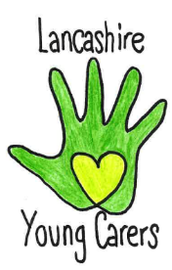
Service Information
Lancashire Young Carers Service
Barnardo’s, 1 Dorothy Avenue, Leyland PR25 2YA Tel: 01772 641002
Email: lancashireyoungcarers@barnardos.org.uk

Who we are
We are funded through Lancashire County Council and East Lancashire Clinical Commissioning Group and are the commissioned service for Lancashire with the responsibility for assessing all young carers across the County.

What we do
We support young carers under the age of 18 who provide regular and ongoing care and emotional support to a family member who is physically or mentally ill, disabled, or misuses substances and are significantly affected by their caring role. Our young carers have a named worker who stays with them from the first point of contact, initial assessment, support and reviews. We offer one to one’s to offer support around their caring role; we support them to access services; support them to take control of their decisions and meet them where they feel comfortable to talk.

What we hope to achieve
We are committed to working with all young carers across Lancashire. Our aim is to assess, support, empower and equip young carers by ensuring they are recognised as a young carer, supported to have a life outside of their caring role, improve their mental health and wellbeing and reduce the negative impact their caring role has on them.

Referrals
We accept referrals from all organisations, services, schools, training providers, health, social care, and self or family referrals. Referral forms can be obtained by contacting us on the number above to receive a paper document via post or email. You can also download our referral form HERE. Once we have received your referral, and have the families’ consent to receive our service, we can arrange to meet with the child/young person to carry out an assessment.

Assessment
Every young carer has a right to an assessment, which considers the level of caring role and the impact this has on their daily life. The assessment will enable the young carer to identify any areas of need and support. We will meet with the child/young person and then discuss with the family and/or referrer to gain more information and share with them what happens next.

Support
Once assessed and one to one support is identified their allocated support worker will develop a support plan with the young carer and their family taking into account what is needed to support the whole family and reduce the negative impact of caring on the young carer, this can be one to one support, targeted group work, referrals and signposting to other services, advocacy and support at meetings.

Lancashire Young Carers | Barnardo’s North Region
lancashireyoungcarers@barnardos.org.uk |Twitter/Instagram: @LYCservice
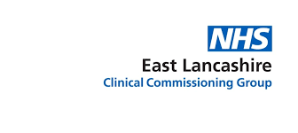

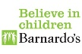
We are also on Facebook- search ‘Lancashire Young Carers’ to find our page.

