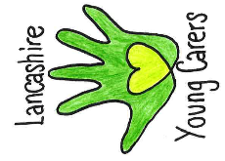
Information
Who is a young carer?
A young carer is under the age of 18 and providing regular and ongoing care and/or emotional support to a family member who is physically or mentally ill, disabled, or misuses substances. Some young carers may not require additional support, others may need some support in school/college. Young carers who are significantly impacted by their caring role may require a referral to Lancashire Young Carers service.
What does a young carer do?
Young carers may provide emotional and/or practical support at home. They may wish to complete a questionnaire document called ‘MACA and PANOC’ which can help school/college to understand what their caring responsibilities are and how it makes them feel. (Guidance on the MACA and PANOC is included in YCARE).
What is the young carer passport?
The young carer passport is a document designed for the young person to complete with a member of staff. It will give an opportunity to discuss any difficulties and what will help you in school/college. This should be reviewed every term, but changes can be made at any time.
What is the young carer card?
The young carer card is to use discreetly in school/college to let a teacher or staff member know that they need specific support around their caring role. This could be around needing to talk to someone about feelings, contacting home, being late to school or needing extra time for homework. The young carer and designated support staff member will have discussed what support is available in school/college when completing the young carer passport.
What does the young carer card look like?
The card is just bigger than a credit card and can be printed and laminated for the young carer to keep hold of. It will include their name, year/form, important dates, and a photo. On the back are some examples of what help might be needed during the school/college day. It will also include the name of the young carers lead and a family contact number.
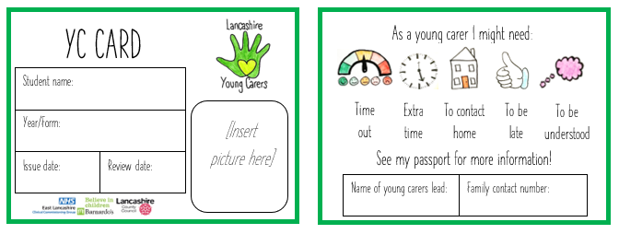

Other help for young carers…
As well as having a young carer passport and card to use in school there is other support available, for example:
- Lancashire Young Carers service
- Kooth
- Children and Family Wellbeing service
- Adult Social Care
Please contact Lancashire Young Carers service if you would like more information on support available.
Lancashire Young Carers | Barnardo’s North Region
lancashireyoungcarers@barnardos.org.uk |Twitter/Instagram: @LYCservice
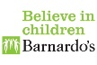
We are also on Facebook- search ‘Lancashire Young Carers’ to find our page.

