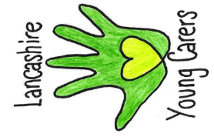
A suggested young carers policy

At (………school/college name…………) we believe that all children and young people have the right to an education, regardless of their home circumstances.

That is why we have adopted Lancashire Young Carers policy for schools/colleges so that together we can relieve some of the negative impact which young carers may face in relation to their caring, home and school/college life.

Our school/college will strive to:

- Designate a member of staff to be the ‘young carers lead’ and ensure young carers are supported and that all pupils are aware of who this is.
- Adopt a healthy attitude to different illnesses to try and reduce stigma attached to illnesses such as mental health problems and disabilities.
- Give information about support services (such as Barnardo’s Lancashire Young Carers service) to pupils.
- Liaise with appropriate agencies (e.g., Barnardo’s, CFWS, Kooth).
- Use the young carer card and passport where appropriate to provide individual support.

Our school/college designated young carers lead is ……………………………………

Signed
Date
Review date
Lancashire Young Carers | Barnardo’s North Region
lancashireyoungcarers@barnardos.org.uk | 01772 641 002 | Twitter/Instagram: @LYCservice

