****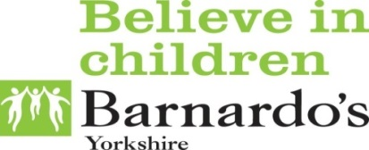

**What is advocacy?**

Advocates are people who help you to work out what you want to say and how to say it.

They will make sure you are listened to and involved in decisions.

**CAPS**

**Children’s Advocacy and Participation Service**

Sometimes having social care or professionals involved in your life can make you feel…



Confused

Angry

Happy

Upset

CAPS might be able to help. Advocates from CAPS can…



Listen to you

Help you to complain if you aren’t happy with your support



Speak up for you

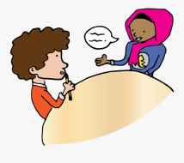



Get answers to questions

Make sure no decisions are made about you without you



Help explain things



Support you at meetings.



Let people know what you think

If you would like to know more about us or if you think you would like support you can get in touch on:

Phone: 01977 552 493|Free phone: 0800 0121 552

Facebook: Wakefield CAPS

E-mail: wakefieldcaps@barnardos.org.uk



