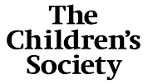
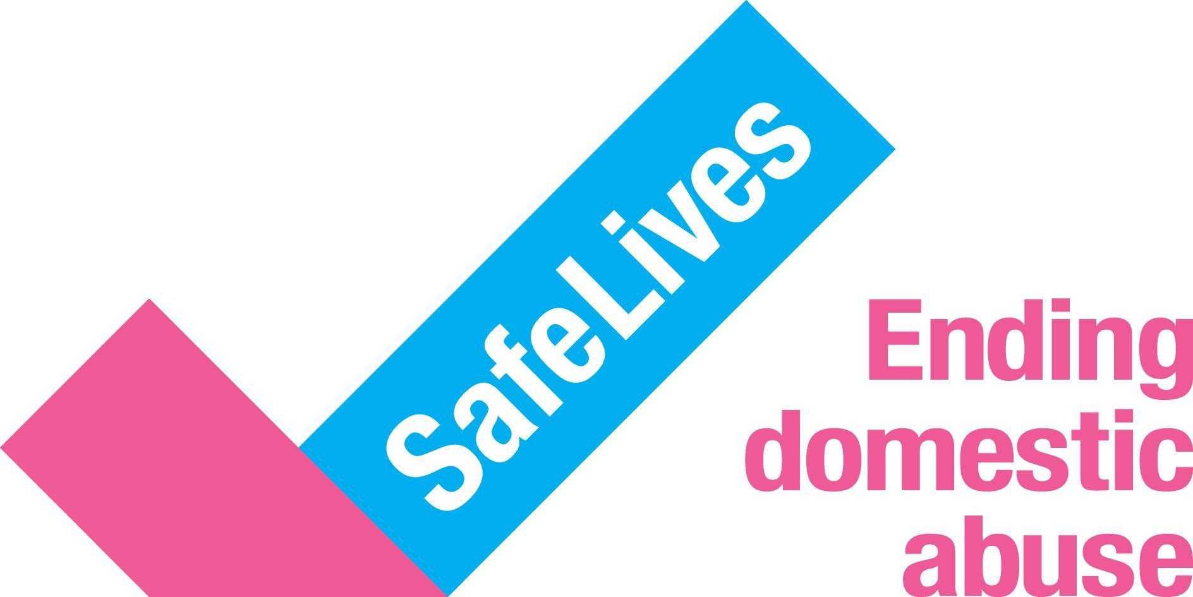
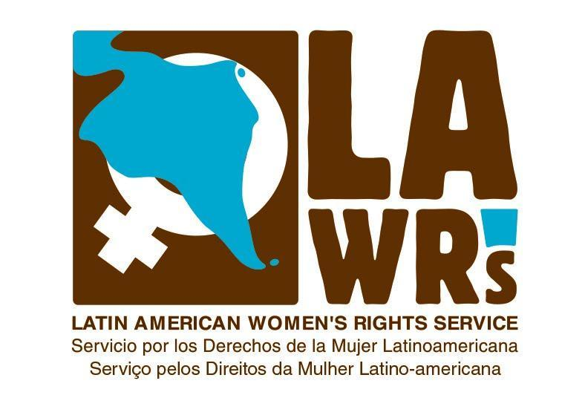
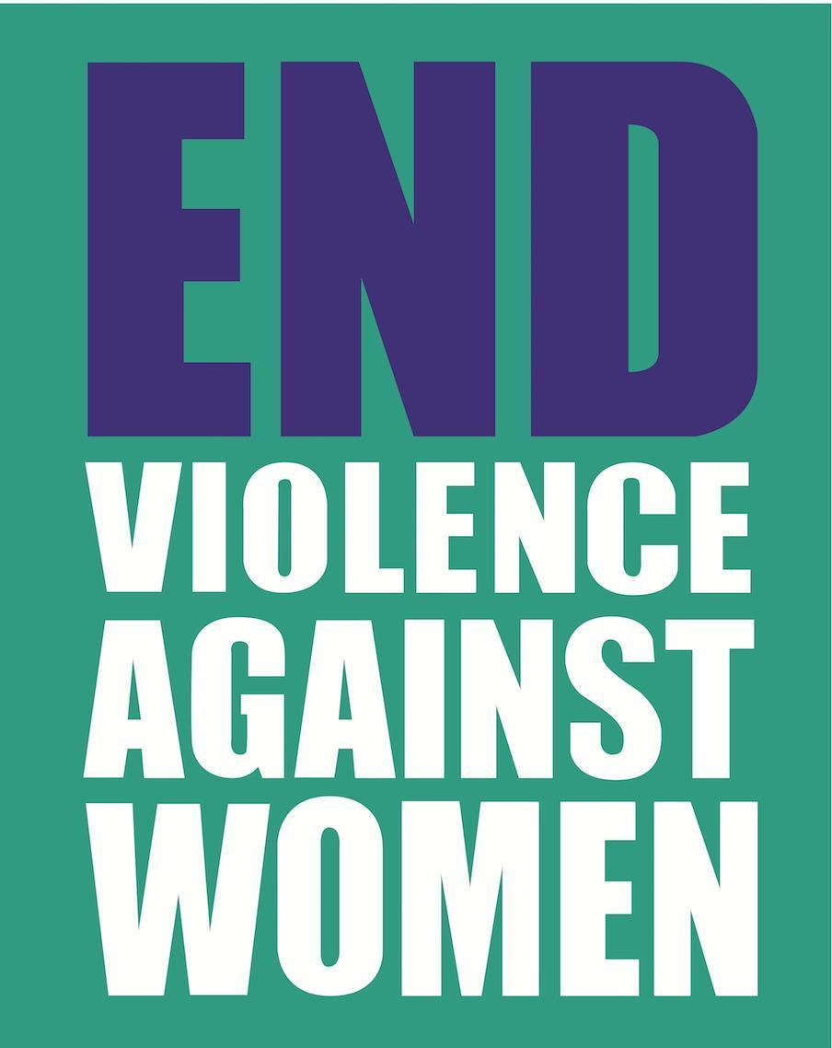
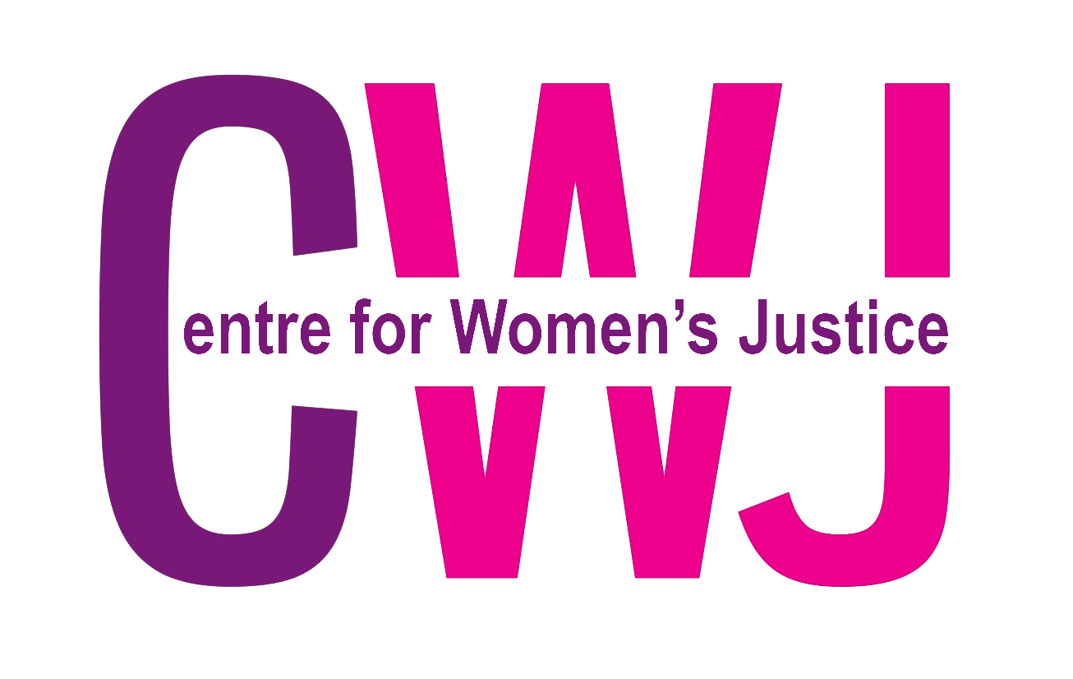
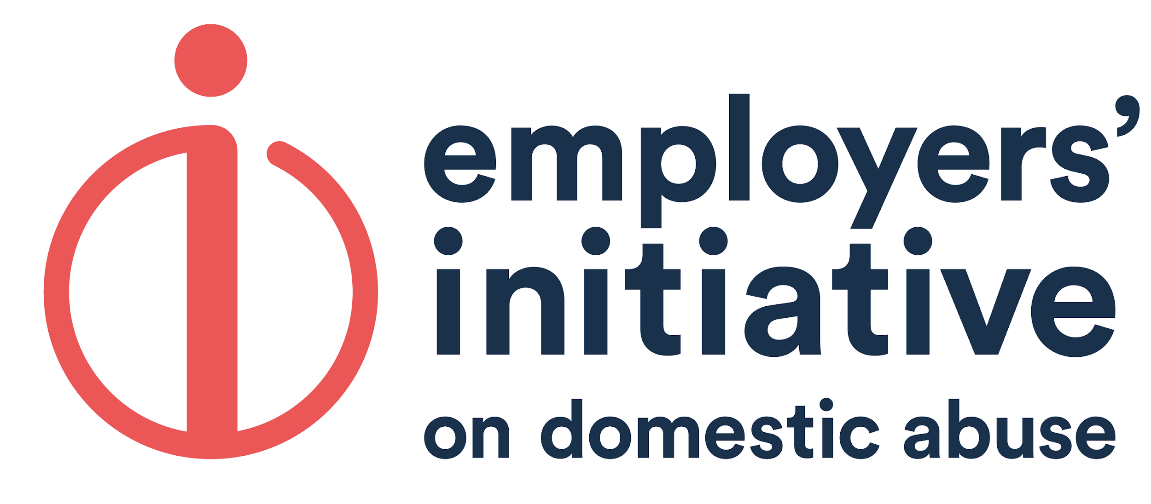
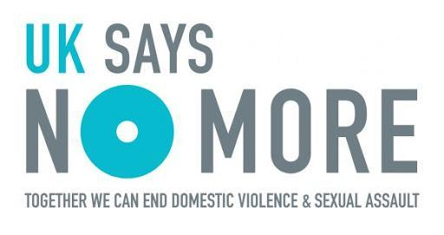
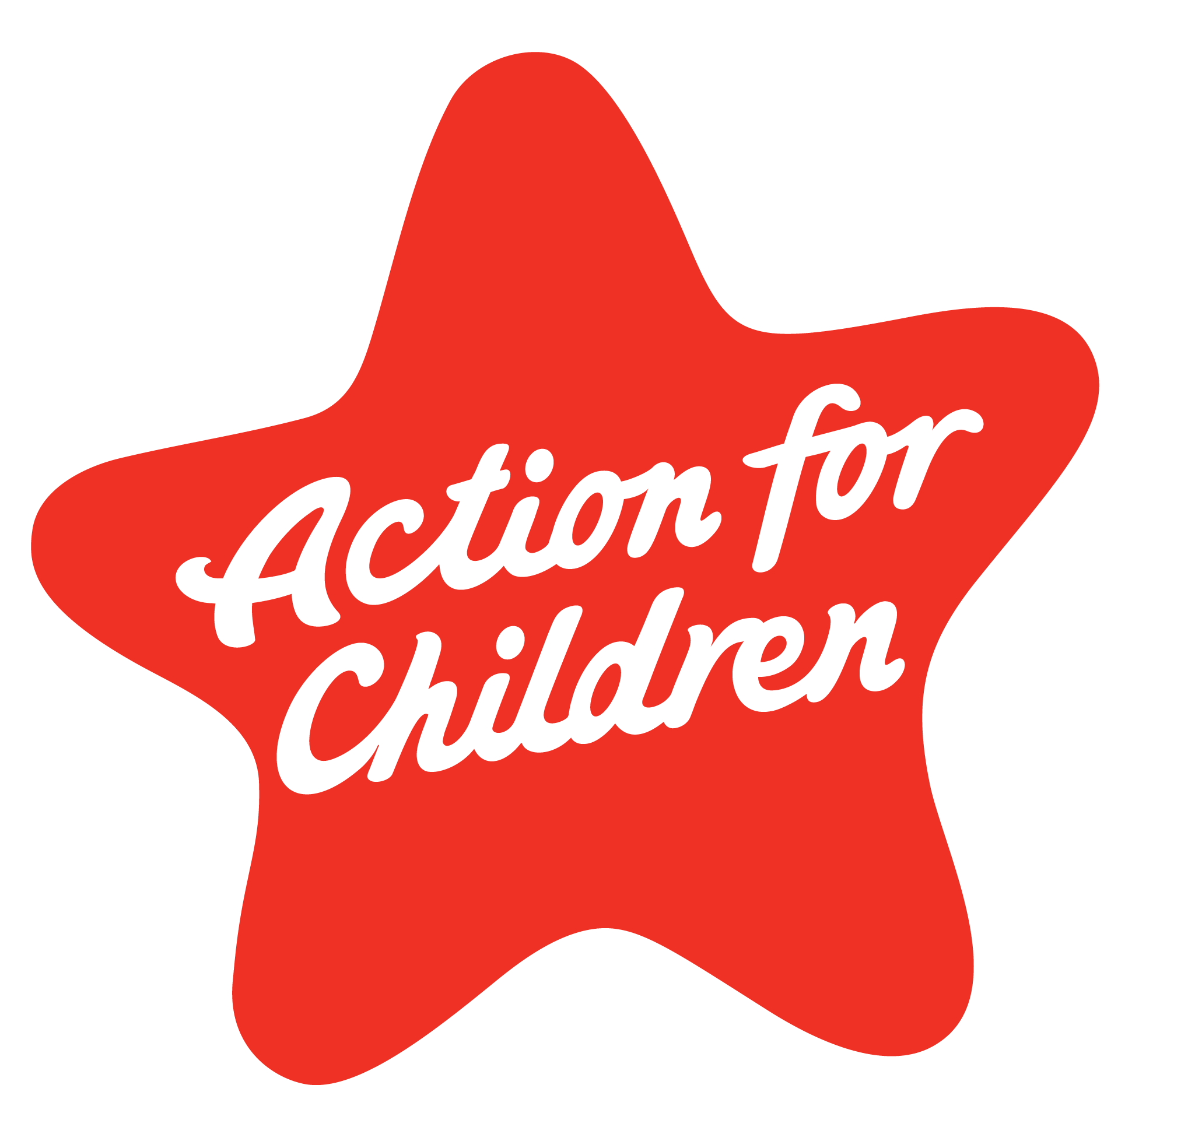
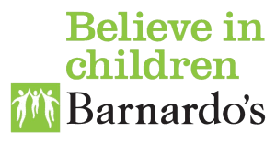
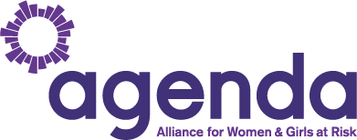
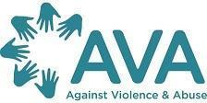
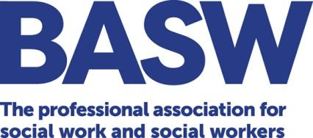
Briefing on the Domestic Abuse Bill
Committee Stage, House of Lords - Amendments NC 176 & 177
The Domestic Abuse Bill is a unique opportunity to transform the response to domestic abuse. Whilst the Bill is welcome, as currently drafted it does not go far enough to achieve its aim - to tackle domestic abuse, and to protect and support all victims, including children.

Amendment NC176 & 177: support for everyone affected by domestic abuse
- As currently drafted the Bill (Part 4) places a duty on local authorities in England to deliver support to victims, including children, in accommodation-based services e.g. refuges.
- However, by excluding community-based services the Bill risks creating a two-tier system where the majority of victims (nearly 70%), including children, who remain at home and will not receive support through this duty.
- Additionally, as the duty only applies to accommodation-based services, we are concerned it could have unintended consequences of diverting funding from community-based services to ensure the duty is met.
- By restricting the scope of the duty to only apply to local authorities and cover accommodation -based support alone, the Government is missing a crucial opportunity to provide a holistic response to domestic abuse and improve the provision of community-based services.
- It is vital that community-based services are placed on the same statutory footing as accommodation-based service. We are therefore proposing that this duty should be replaced or amended. Amendments 176 & 177:
  - Places a duty on all relevant public authorities to commission specialist domestic abuse support services for all persons affected by domestic abuse. This amendment would go further than the current duty as it would:
    - Provide support to all victims, no matter where they live and regardless of their status, through community based and accommodation based services, including specialist services, enabling support for prevention, early intervention and late intervention.
    - Provide programmes for perpetrators to prevent re-offending.
    - Apply to all relevant public authorities as domestic abuse services are commissioned by a range of agencies, not just local authorities, such as Police and Crime Commissioners.

This amendment is also supported by the Designated Domestic Abuse Commissioner, the Victims’ Commissioner and the Children’s Commissioner.

- Majority of victims of domestic abuse are supported by community-based services

As currently drafted the Bill (Part 4) places a duty on local authorities in England to deliver support to victims, including children, in accommodation-based services e.g. refuges. This Bill risks creating a two-tier system as, the Justice Secretary said at Second Reading in the House of Commons, the reality is the vast majority of victims, an estimated 70%, of those who seek support, never set foot in a refuge and remain at home or in alternative housing. Often these victims are supported by community-based services, for example, more than 65,000 adults and 85,000 children at the highest risk of serious harm or murder are supported by community-based services.

During the first national lockdown, calls to the National Domestic Abuse Helpline up by 49% and domestic abuse homicides, including children, are thought to have more than doubled. Similarly, NSPCC’s Helpline has seen a 10% increase in calls relating to concerns about children in households where domestic abuse is taking place. The impact of COVID-19 makes it even more important that the Bill is strengthened by including community-based support services. A position supported by the Domestic Abuse Commissioner who told MPs during the Committee Stage in the House of Commons: “what I have always thought is missing from the Bill and would greatly support the services is the inclusion of community-based services in the statutory duty.”

- The Bill could improve the provision of specialist community-based support

- Support for all child victims of domestic abuse

As it currently stands the Bill will only ensure that children in safe accommodation receive statutory support; leaving children living at home or in the wider community without statutory support.

Analysis by the Children’s Commissioner, pre-COVID-19, found that 831,000 children in England are living in households that report domestic abuse. Domestic abuse remains the most common factor amongst children assessed as ‘in need’ by local authorities in England.

Children are the ‘hidden victims’ of domestic abuse which has devastating effects on their wellbeing (mental and physical), educational outcomes, and likelihood of entering abusive relationships. We welcomed the Government’s amendment to the Domestic Abuse Bill in July 2020 to recognise children under the age of 18 as victims of domestic abuse. It is an important step forward in ensuring that children are seen as victims and the impact it has on their lives is recognised by professionals. However, this will not ensure that all children will be able to access support.

We know access to specialist support services for children, such as a Young People’s Violence Advisors (YPVAs) Service, reduces the impact of domestic abuse and improves children’s safety and health outcomes. However, there is already existing evidence of a lack of provision of services for children affected by domestic abuse. Action for Children found that children faced barriers to access support in two-thirds of the local authorities in England and Wales that took part in the research, and over 10% of these had no specialist support services available for children at all.

For services that do exist the pandemic has placed additional pressure on them. A SafeLives survey of frontline domestic abuse services found that 42% were not able to effectively support child victims of domestic abuse at this time. At the same time, the risk to children has increased significantly. During the first national lockdown, 57% of Barnardo’s frontline staff are concerned about an increase in family conflict and stress, while 45% report a decrease in referrals due to families having less contact with services. There is a serious risk that children living in abusive households are going unrecognised and unsupported, and the numbers are growing.

Whilst the Government has agreed that the Domestic Abuse Commissioner is to undertake a review of community-based services this is estimated to take ‘some 12 months’ - a year too long for children and young people who urgently need support now.

It is vital that all children affected by domestic abuse can access specialist support no matter where they live, this could be achieved through this amendment.
- Support for young people in abusive intimate relationships

Young people are the group most likely to be in an abusive relationship. A survey of 13 to 17 year olds found that 25% of girls and 18% of boys reported having experienced some form of physical violence from an intimate partner. However, The Children’s Society found the majority (77%) of local authorities, who responded to their FOI, do not have a policy or protocol in place for responding to under 16s experiencing teenage relationship abuse, with just 39% of local authorities providing a specialist support service for under 16s and 26 local authorities providing no specialist support nor any additional support for this age group.

As it currently stands the Bill considers young people aged 16 or over in an abusive relationship, could be considered perpetrators. As a result, there is a danger that these young people will be criminalised and refused the opportunity to change their behaviour and forge a positive future.

Young people who may present as abusive in teenage relationships require a response that recognises them as children and provides specialist support to address their harmful behaviour. This amendment would ensure young people in abusive relationships are able to access specialist support, such as YPVAs, to address their harmful behaviour.
- Equal protection for all victims and survivors

Domestic abuse has a devastating impact on the lives of victims and access to support is vital for their recovery and the chance to rebuild their lives. Some victims, such as disabled, LGBT+ and migrant victims, face additional barriers to accessing support.

i) Disabled women

Disabled women are twice as likely to experience domestic abuse as non-disabled women, they are more likely to experience abuse for a longer period of time before accessing support, and their abuse is often directly linked to their impairments and perpetrated by individuals they are most dependent on for care. It is also estimated that less than 2% of refuges are wheelchair accessible - meaning that even where services do exist they are not accessible.
ii) LGBT+
LGBT+ individuals face additional barriers to accessing services under normal circumstances and even more so with restrictions put in place because of COVID-19. LGBT+ victims and survivors present with higher levels of risk and complex needs by the time they access support - mental health problems and self-harm are the most significant needs identified. Research from Galop (2019) found LGBT+ specialist domestic abuse services are largely unavailable within most local authority areas in England and Wales.
iii) Migrant victims and survivors

Some migrant victims and their children can face destitution due to a lack of entitlement to welfare support due to their immigration status, and fear of deportation; all of which has been exacerbated by the current COVID-19 related restrictions. This can be particularly acute for women with insecure immigration status and no recourse to public funds (NRPF).

Although women with NRPF who are caring for children are theoretically entitled to continued support for their children under Section 17 of the Children Act, these women are being refused help despite Section 17 duties. Of the 20 women with NRPF who were fleeing with children in 2017-18 social services either refused to fund a refuge space or provide emergency accommodation, or offered to accommodate the children in emergency accommodation but not the mother.

As the Bill currently stands it does not address the barriers faced by all migrant victims in accessing support. Thus, is not compliant with the Istanbul Convention which requires protection to be provided without discrimination on any grounds, including migrant and refugee status. The Istanbul Convention was signed by the UK on 8 June 2012 and the Government intends to ratify it through this Bill, however it must ensure that any statutory duty will allow all survivors access to protection equally.
The need for equal protection in the Bill was endorsed by the Joint Committee on the draft Domestic Abuse Bill, who recommended an additional clause in the Bill, imposing on public authorities dealing with a victim or alleged victim of domestic abuse, or making decisions of a strategic nature about how to exercise functions, a duty to have due regard to the need to protect the rights of victims without discrimination on any of the grounds prohibited by Article 4, paragraph 3 of the Istanbul Convention.
This amendment would introduce the principle of non-discrimination into the Bill, thereby strengthening the Bill to protect and provide support which is inclusive and accessible to all victims, regardless of immigration status.

- Provision for adult perpetrators

Less than 1% of perpetrators currently receive an intervention to change their behaviour. A lack of funding for perpetrator services was recently identified as the biggest issue by frontline practitioners across England and Wales. Based on evidence from SafeLives’ Every Story Matters platform, 82% of respondents said that they supported the introduction of more perpetrator programmes, nearly 80% wanted tougher sentences, 74% wanted mental health support for perpetrators, and 73% wanted public awareness campaigns specifically targeted at perpetrators.

We believe that by missing out specialist quality-assured programmes for perpetrators, the current statutory duty (in part 4) will fail to place appropriate emphasis on the person causing the harm – the perpetrator – instead placing the onus on the victim to leave their home, disrupt their children’s lives and potentially isolate themselves from their community, networks and work. A holistic approach which supports everyone affected by domestic abuse, including perpetrators is needed instead. For this reason, this amendment would ensure that all adult perpetrators are able to access effective quality assured perpetrator programmes to prevent offending and re-offending.

- The Bill risks curtailing funding for community-based services and excluding other public authorities who commission domestic abuse services

Domestic abuse services are not only commissioned by local authorities, they are also often funded by other public authorities including Police and Crime Commissioners and health bodies. The draft statutory guidance emphasises that tackling domestic abuse requires a multi-agency approach, which would require a wider group of public authorities who commission community-based support services to be involved. However without a statutory duty on those authorities there is no legal obligation for their involvement; and these services might not be commissioned.

Cllr Simon Blackburn, Chair of the Local Government Association Safer and Stronger Communities Board, told MPs during the Committee Stage in the House of Commons: “Funding for domestic abuse services comes from the Government to the third sector, Police and Crime Commissioners, health, local authorities we need to think about whether the duty should apply to those authorities as well, but in broad terms Local Government Association welcomes the duty. But they want to see early intervention and prevention and community services being given as much weight as accommodation based services.”

During the Committee Stage in the House of Commons the Domestic Abuse Commissioner told MPs: “In order to address the breadth of domestic abuse services, the statutory duty must encompass those community-based services that are accessed by the majority of victims, survivors and their children, and must also include quality provision for perpetrators. I have very real concerns about Local Authorities redistributing their funding simply to meet the statutory duty, and therefore deprioritising those critical community-based services that can intervene earlier and prevent a survivor from being forced to flee to a refuge. There is already ample evidence to support this, and while my mapping work may well add to this evidence base, it is wholly unnecessary for Parliament to wait for it to complete before considering this issue.

Women’s Aid have estimated that it will cost £393million per year to implement the duty on local authorities (Part 4), however the Government’s has only allocated £125million in the one-year Spending Review for 2021/22. This risks diverting funding from community-based domestic abuse services which the majority of victims rely on. The Government has not committed to undertaking an impact assessment that the duty on local authorities to provide services to victims in accommodation-based services will have on the provision of community-based services.

For more information please contact Claire Stewart, Senior Public Affairs Officer, on 07493771170 or claire.stewart@barnardos.org.uk

This briefing is also supported by the Equality and Human Rights Commission, the Children’s Commissioner for England and Dr Emma Katz, Liverpool Hope University.
Domestic Abuse Bill, as introduced 7th July 2020 to the House of Lords
SafeLives. Second Reading Briefing
Examples of community based services include protective measures and action taken to protect persons against domestic abuse, counselling and other support; advocacy services; specific children’s support services; helplines; legal services and welfare support services.
Domestic Abuse Bill, as introduced 7th July 2020 to the House of Lords
Hansard, 28 April. Domestic Abuse Bill Second Reading.
SafeLives, Briefing for Second Reading: Domestic Abuse Bill [HoC]
SafeLives, 2020. New Domestic Abuse Bill. 4 BBC, April 2020. Coronavirus: Domestic abuse cal
BBC, April 2020. Coronavirus: Domestic abuse calls up 25% since lockdown.
Guardian, April 2020. Domestic abuse killings more than doubled amid Covid-19 lockdown.
Parliamentary Debates, Public Bill Committee, June 2020. Domestic Abuse Bill First Sitting.
Office of the Children’s Commissioner for England, Childhood vulnerability in numbers
Department for Education, Characteristics of children in need: 2019 to 2020, England.
https://publications.parliament.uk/pa/bills/cbill/58-01/0141/amend/domestic_rm_rep_0629.pdf
A YPVA service is for young people ages 13-19 who are experiencing domestic abuse or who have harmed a partner or family member themselves.
Action for Children, 2019. Patchy, piecemeal and precarious: support for children affected by domestic abuse.
SafeLives,2020. Domestic abuse frontline service COVID-19 survey results.
Barnardo’s, 2020. Quarterly Practitioner Survey on the impact of Covid-19.
Minister for Safeguarding gave details regarding the timescale of the review (HC 20 May, W43470)
Ibid
The Children’s Society, May 2020. Missing the mark.
SafeLives, 2017. Disabled Survivors Too: disabled people and domestic abuse.
Women’s Aid, 2020. The domestic abuse report 2020
https://safelives.org.uk/sites/default/files/resources/Free%20to%20be%20safe%20web.pdf
http://www.galop.org.uk/recognise-respond-strengthening-advocacy-for-lgbt-survivors-of-domestic-abuse-2/
See Joint briefing on the Domestic Abuse Bill for more information on migrant victims.
Women’s Aid, 2019. No Woman Turned Away Project.
Article 4, paragraph 3 of the Council of Europe Convention on preventing and combating violence against women and domestic violence.
Equality and Human Rights Commission (EHRC), non-discrimination in the provision of services is required under the UK’s international human rights obligations. See: EHRC, 2020. Domestic Abuse Bill Second Reading Briefing.
SafeLives, 2020. Briefing for the Second Reading of the Domestic Abuse Bill.
Ibid
Safelives, 2019. Response to the Domestic Abuse Bill Consultation.
Parliamentary Debates, Public Bill Committee, June 2020. Domestic Abuse Bill First Sitting.
Parliamentary Debates, Public Bill Committee, June 2020. Domestic Abuse Bill First Sitting.
Women’s Aid, Briefing for the Report Stage and Third Reading of the Domestic Abuse Bill, June 2020.
HM Treasury, Spending Review 2020. Pg74.

